
TwitterVane

User
Manual

05 February 2013
Contents


Introduction 3
About TwitterVane 3
About this document 3
Where to find more information 3
System Overview 4
Purpose and scope 4
How does it work? 4
TweetView: Home Page 5
TweetView: Collections 6
TweetView: Reports 10
Criteria driven reports 10
Browse Reports 12

Introduction

About TwitterVane

TwitterVane is a tool for leveraging the power of the crowd to select websites for web archiving. It enables curators to define web collections and identify trending Tweets and associated URLs that are relevant to those collections.

About this document
This document is the TwitterVane User Manual. It describes how to use TwitterVane though its web browser interface. It assumes your system administrator has already set up the system.

Where to find more information
The public resources for TwitterVane, including the source code, binaries and documentation, is available through the TwitterVane Open Source GitHub project:

https://github.com/ukwa/twittervane

System Overview

Purpose and scope
The application has been designed to stream Tweets directly from Twitter and store them for analysis. The analysis consist of expanding any shortened URLs associated with the Tweets using the Bitly expander service and associates the Tweets with the Web Collections that have been defined.

How does it work?
TwitterVane is divided into three major components

TweetView
TweetView is the curator web interface where users define collections and search terms that will be used to collect Tweets. A series of reports is also provided to identify popular Tweets and top URLs by collection.

TweetStreamAgent
TweetStreamAgent streams Tweets directly from Twitter and stores them in the TwitterVane database for further analysis. It uses the search terms that have been defined by curators through TweetView to filter the Tweet stream. This is a management web interface that enables users to control and configure the Tweet stream.

TweetAnalyser
TweetAnalyser runs periodically (after a specific number of Tweets have been received from the Tweet stream) and expands any shortened URLs using Bitly. Any Tweet URLs are then resolved to the web collection using the collection’s search terms.

TweetView: Home Page

The home page for TwitterVane is pictured below:
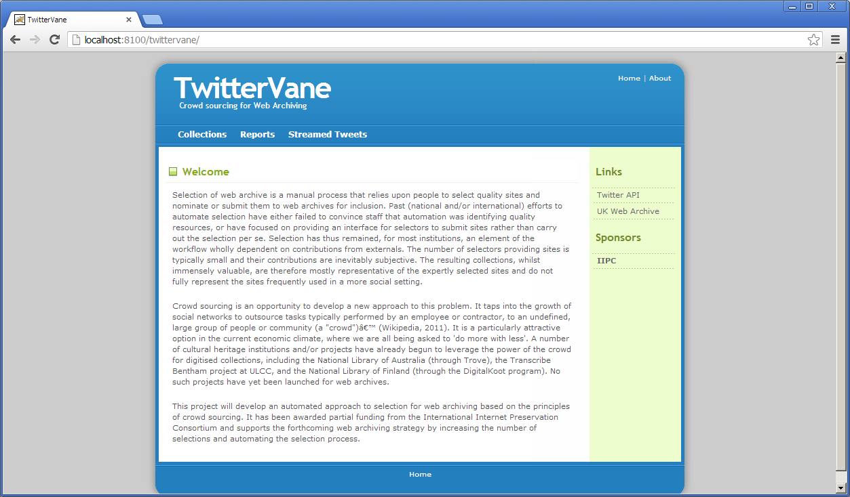

The top navigation menu items give access to the functionality to create and manage web collections:

Collections – create, view and manage web collections and associated search terms

Reports – view and run the criteria based reports and ‘browse reports’

Streamed Tweets – view the latest Tweets from the Tweet Stream

The left hand navigation menu contains TwitterVane’s related links.

TweetView: Collections

The Collections page displays the Web Collections that are currently defined on the system, the search terms associated with the collection, and the start and end dates within which Tweets should be collected:

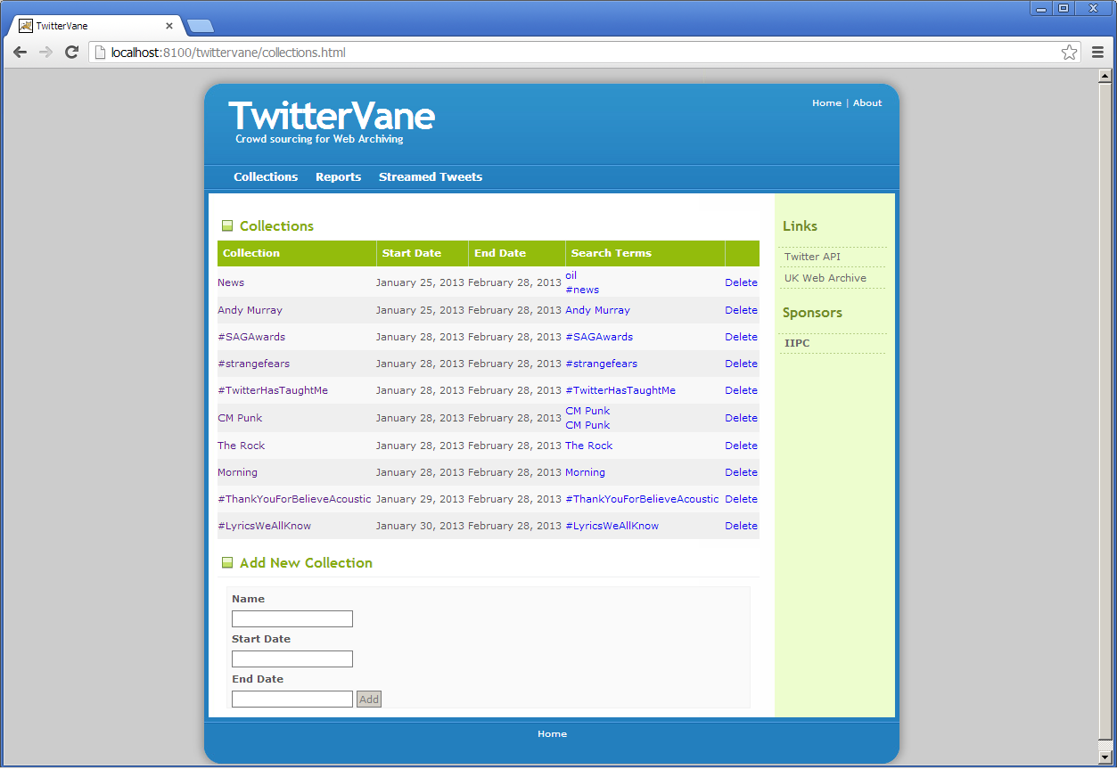

To create a new collection, fill out the name, start and end date in the fields at the bottom of the screen and click ‘Add’.

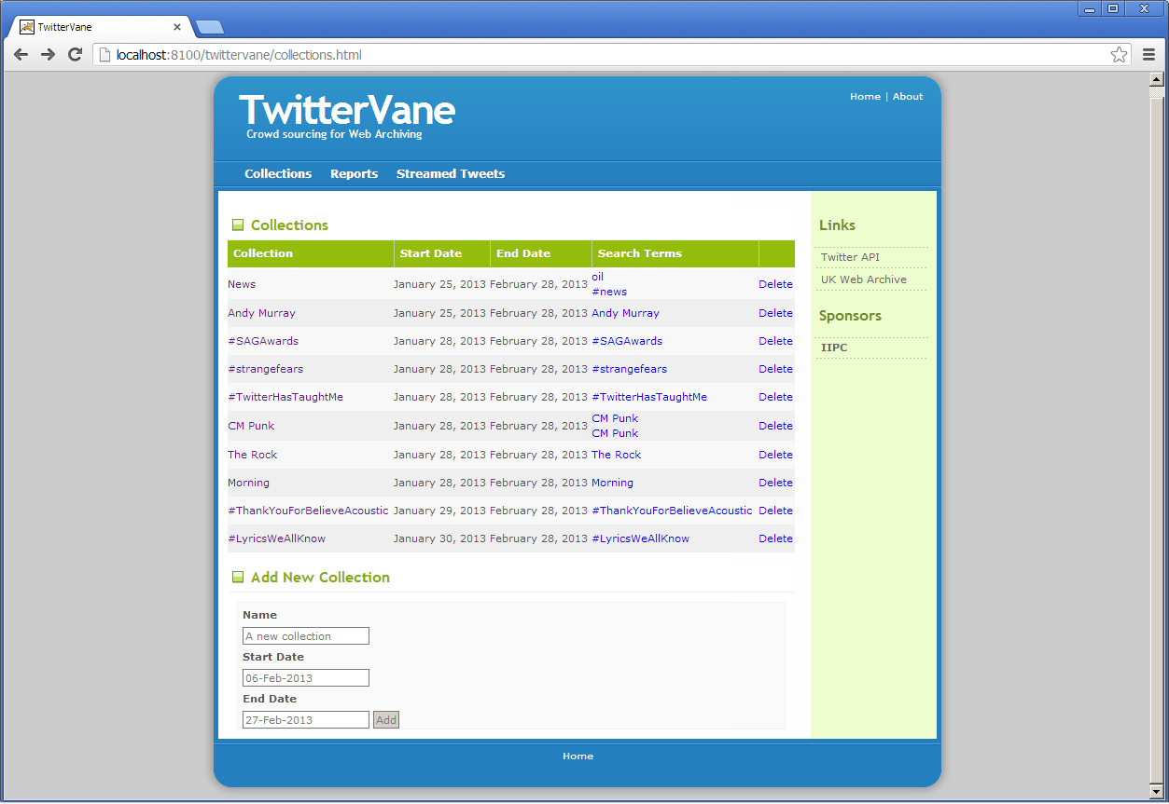

The collection then appears in the list:

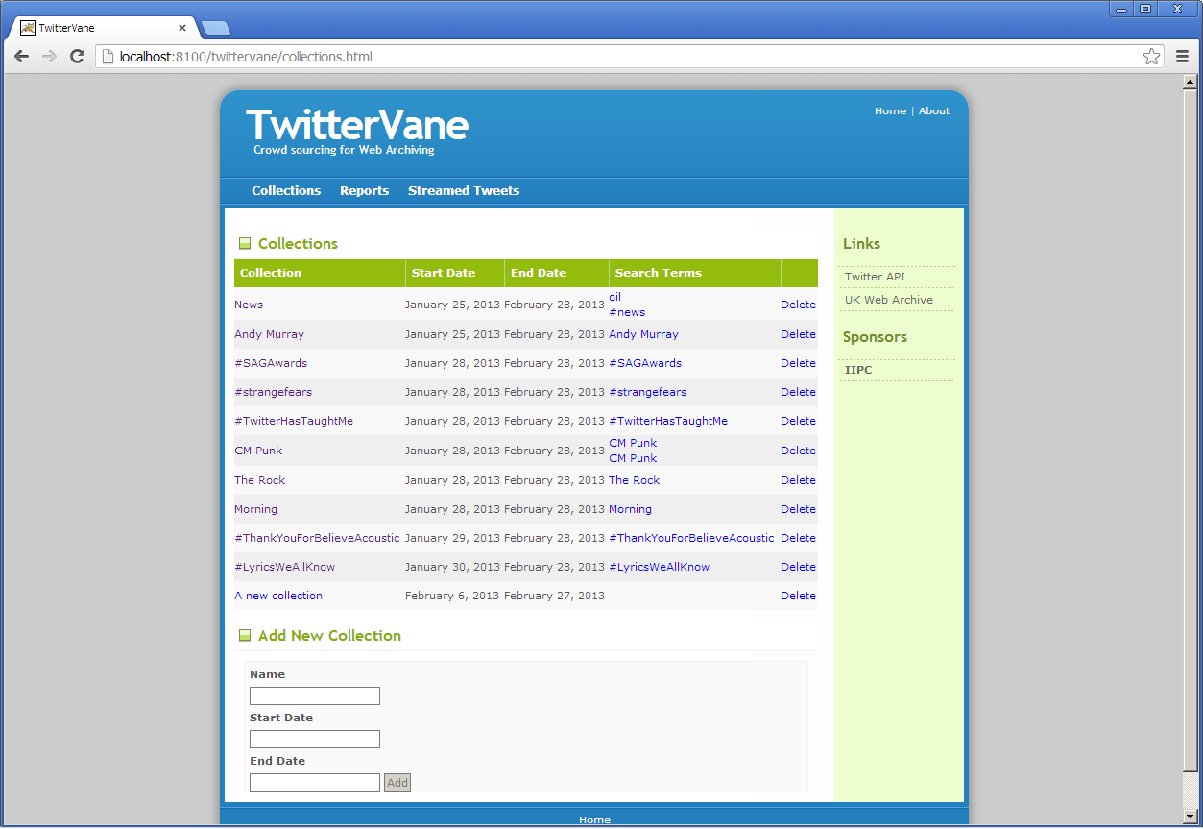

To add search terms to the collection, click on the collection name:

The Edit Collection page is then displayed where the collection details can be modified:

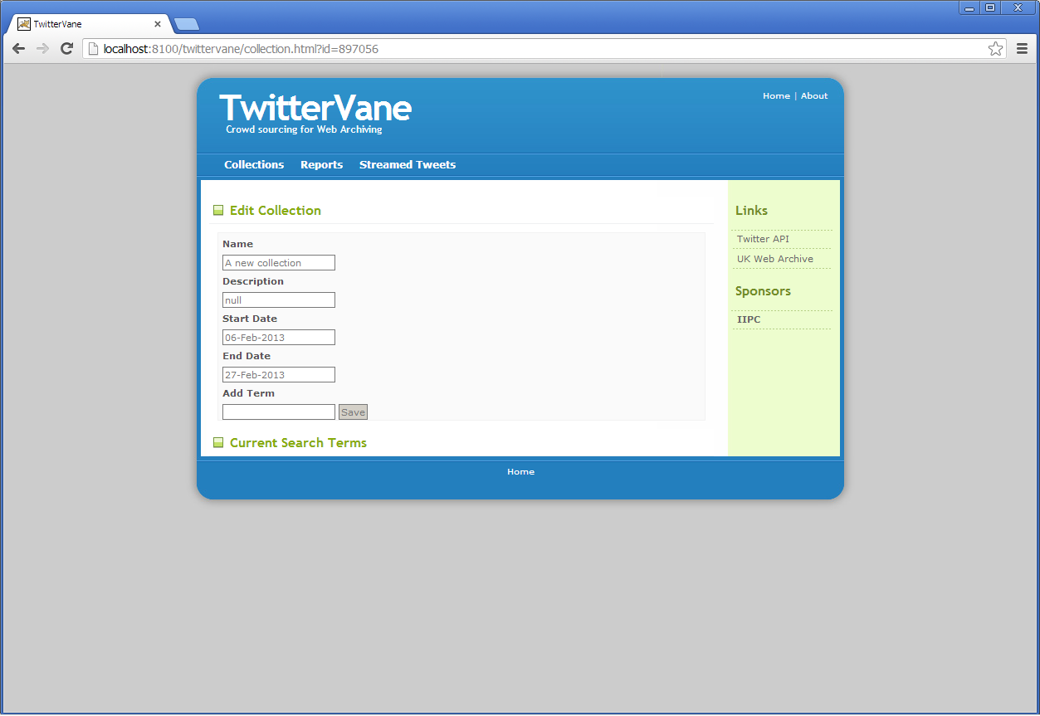

Enter the new search term into the ‘Add Term’ text box at the bottom of the page and click ‘Save’:
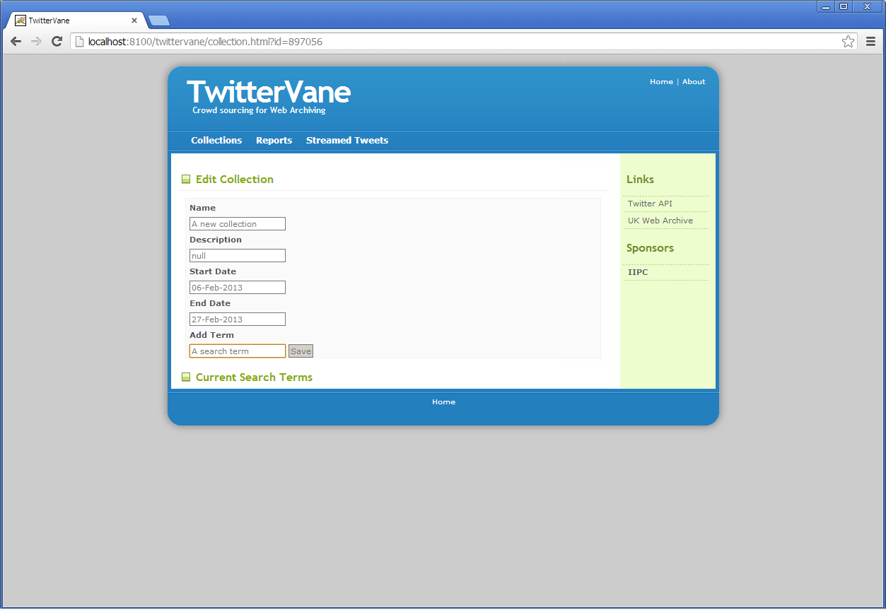

The search term is then listed at the bottom of the page:

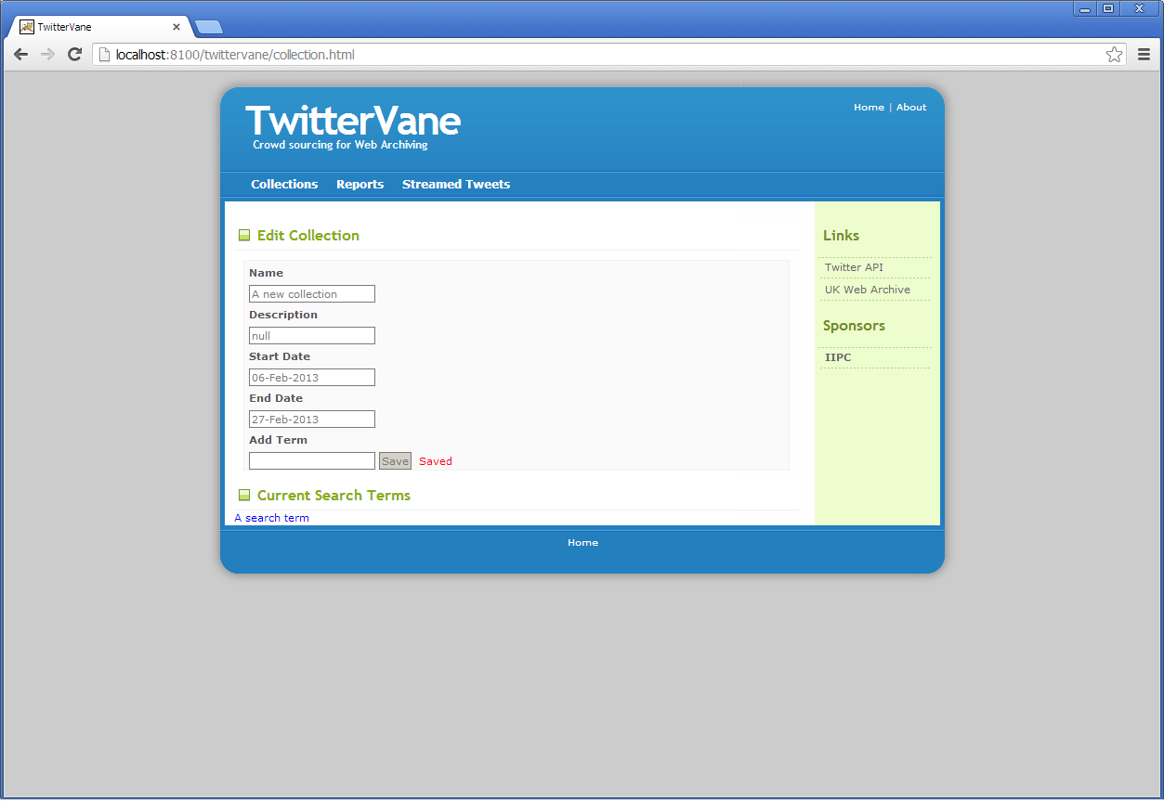

To delete a collection, use the delete link on the right of the collection on the Collections screen:
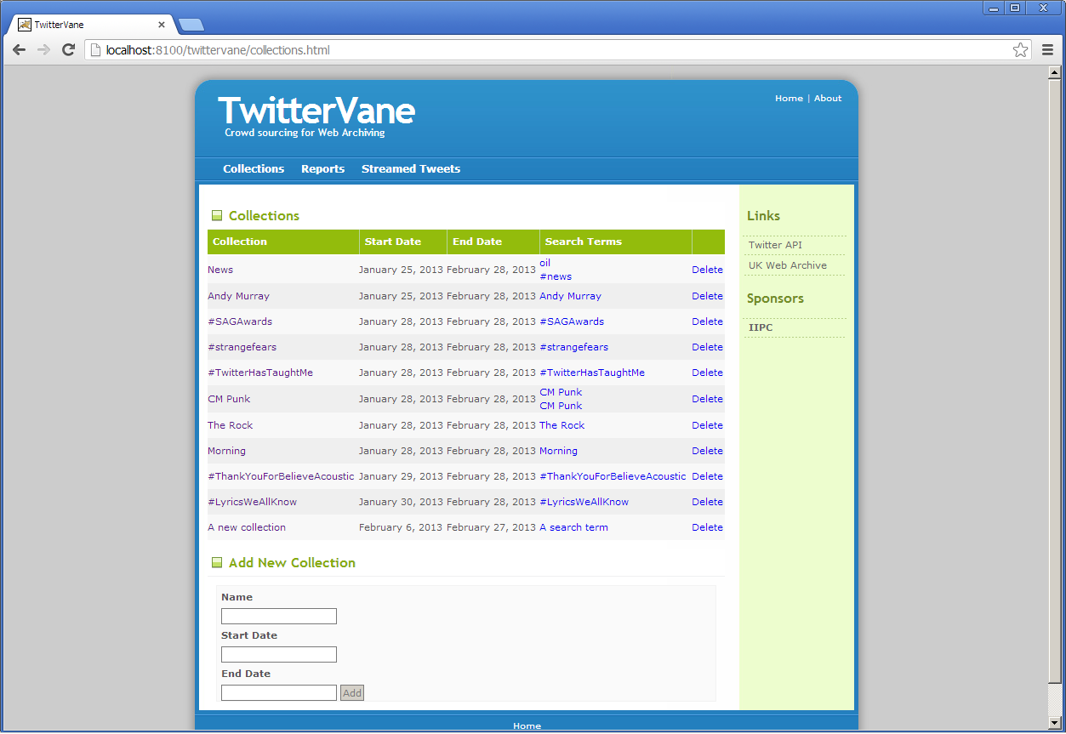

TweetView: Reports

There are two types of report available in TwitterVane:
- Criteria driven reports
- ‘Browse Reports’

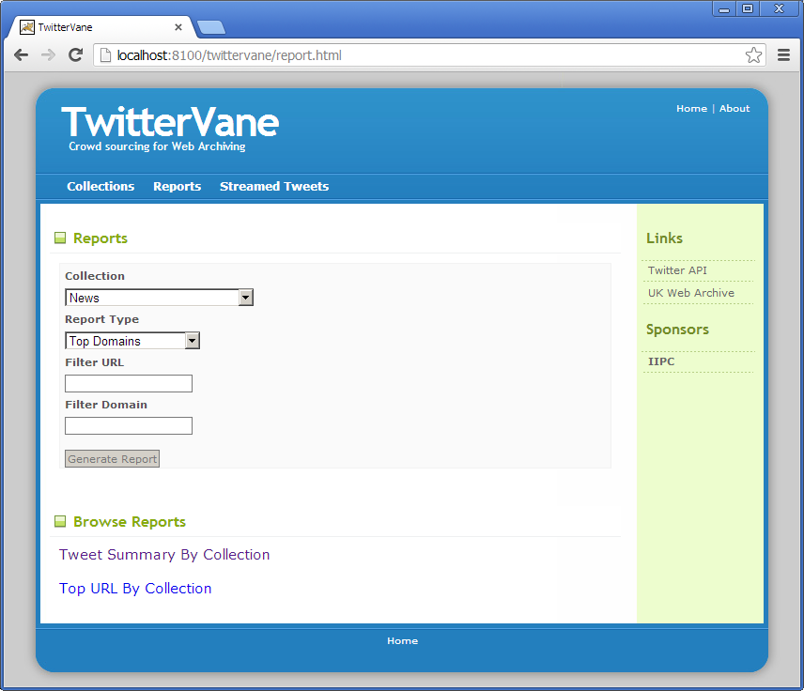

Criteria driven reports
TwitterVane has four criteria reports defined:
- Top Domains – returns the first 100 domains containing the greatest number of URLs for the selected Web Collection. The results are sorted on the number of URLs in descending order
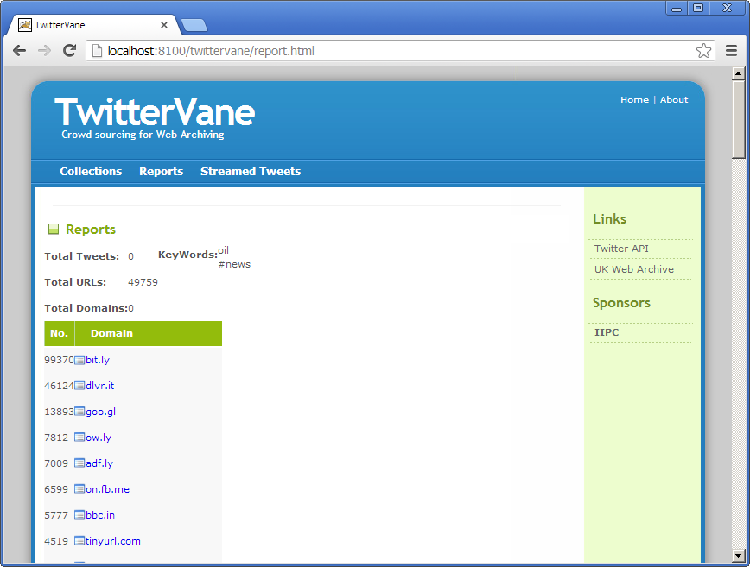
- Top URLs - returns the top 100 expanded URLs for the selected Web Collection.
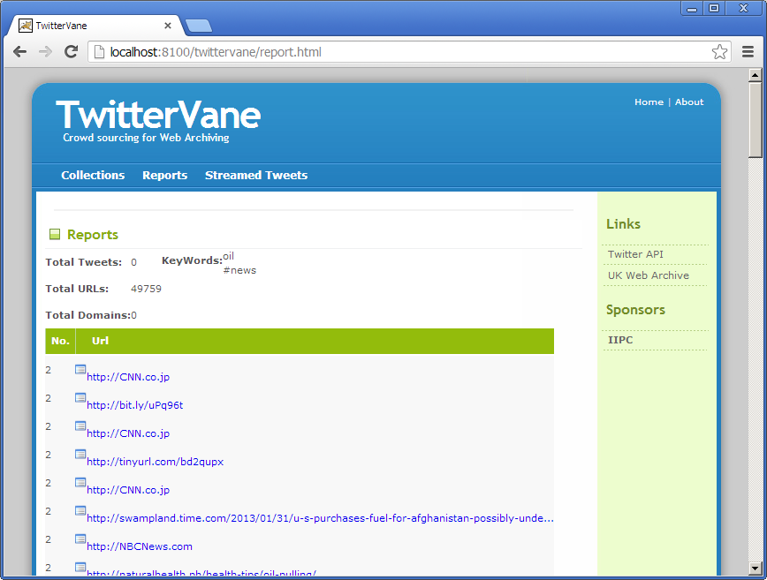
- Top URL by Retweet - returns the most popular expanded URL for the selected Web Collection. Popularity is re-tweet count of the Tweet received from Twitter.
- Failed Analysis - returns all URLs that encountered errors when analysed.
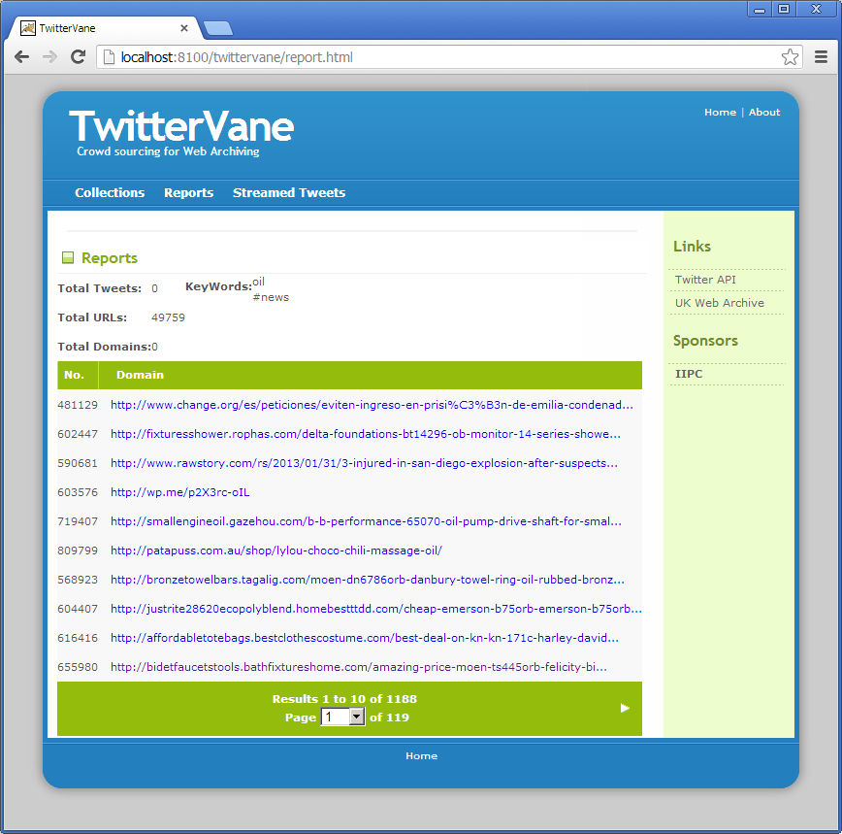

Browse Reports
There are two ‘browse report’ defined for TwitterVane. The reports contains sortable columns and the sort order can be changed by clicking on the column header.
- Tweet Summary By Collection - displays the number of Tweets, URLs, expanded URLs and errors for each collection.
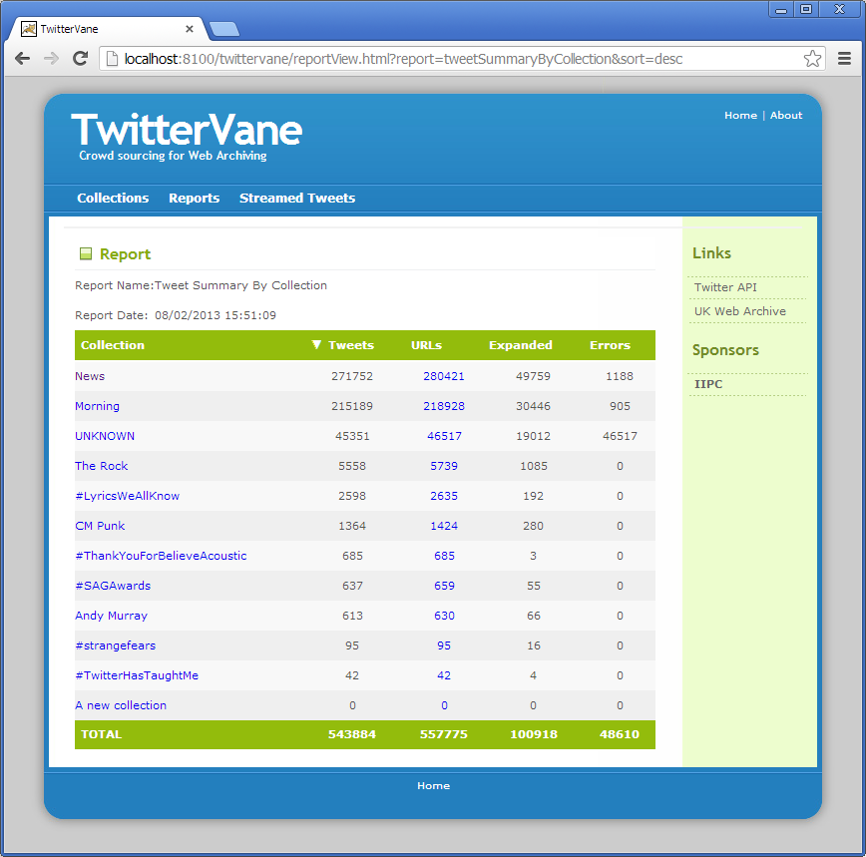
Clicking the collection name will display the number of Tweets by time period for the collection. The time periods are represented graphically for the past week, month and year.
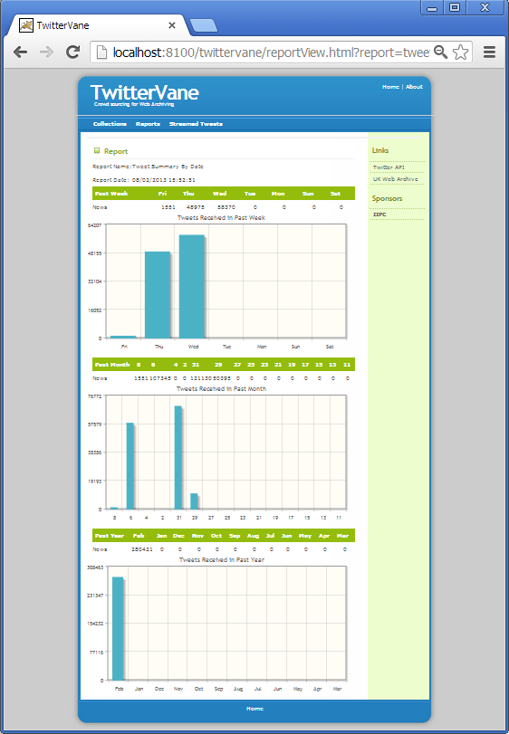
Clicking on the figure under the URLs column for the collection will display all the URLs (expanded or unexpanded) for that collection.
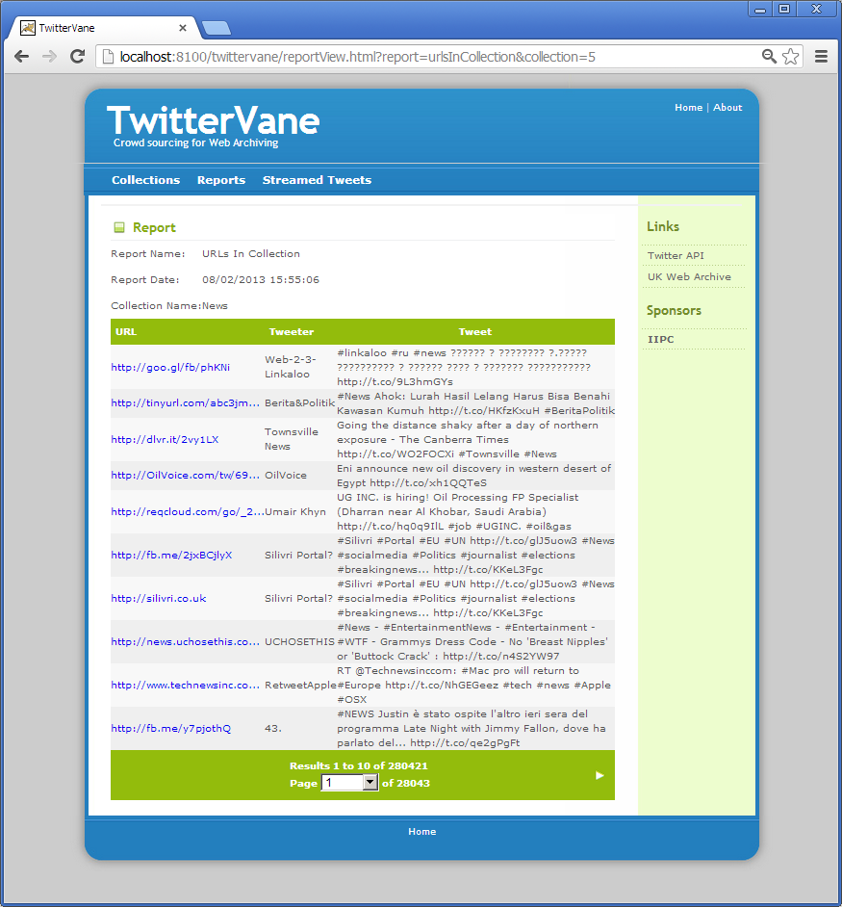
- Top URL By Collection - displays the top URL, Tweets and Re-Tweets for each collection. The top URL is the most frequently occurring URL in that collection.
